**Experiment No. 08**

**Experiment Name:** Implementation of FCFS scheduling algorithm .

**Aim and Objectives:**

* What is FCFS scheduling algorithm?
* How to implementation this algorithm

**Source Code:**

|  |
| --- |
| #include<iostream>  using namespace std;  int main()  {  int n,bt[20],wt[20],tat[20],avwt=0,avtat=0,i,j;  cout<<"Enter total number of processes(maximum 20):";  cin>>n;  cout<<"\nEnter Process Burst Time\n";  for(i=0;i<n;i++)  {  cout<<"P["<<i+1<<"]:";  cin>>bt[i];  }  wt[0]=0; //waiting time for first process is 0  //calculating waiting time  for(i=1;i<n;i++)  {  wt[i]=0;  for(j=0;j<i;j++)  wt[i]+=bt[j];  }  cout<<"\nProcess\t\tBurst Time\tWaiting Time\tTurnaround Time";  //calculating turnaround time  for(i=0;i<n;i++)  {  tat[i]=bt[i]+wt[i];  avwt+=wt[i];  avtat+=tat[i];  cout<<"\nP["<<i+1<<"]"<<"\t\t"<<bt[i]<<"\t\t"<<wt[i]<<"\t\t"<<tat[i];  }  avwt/=i;  avtat/=i;  cout<<"\n\nAverage Waiting Time:"<<avwt;  cout<<"\nAverage Turnaround Time:"<<avtat;  return 0;  } |

**Output:**

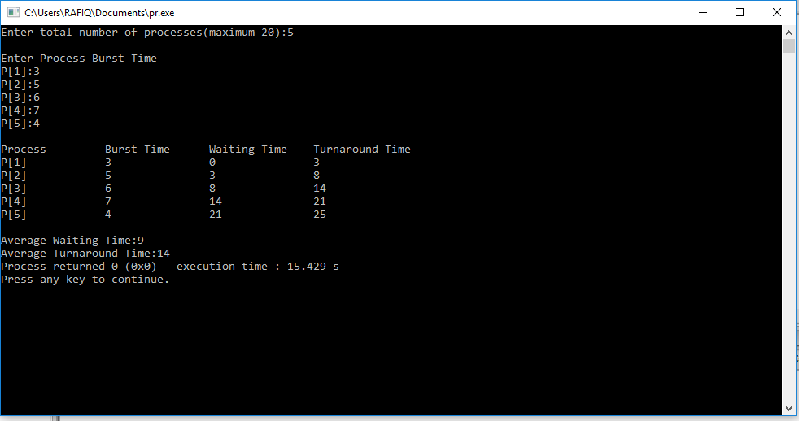

**Conclusion:** First in, first out (FIFO), also known as first come, first served (FCFS), is the simplest scheduling algorithm. FIFO simply queues processes in the order that they arrive in the ready queue. In this, the process that comes first will be executed first and next process starts only after the previous gets fully executed.